Freedom of Expression - Com. 3070

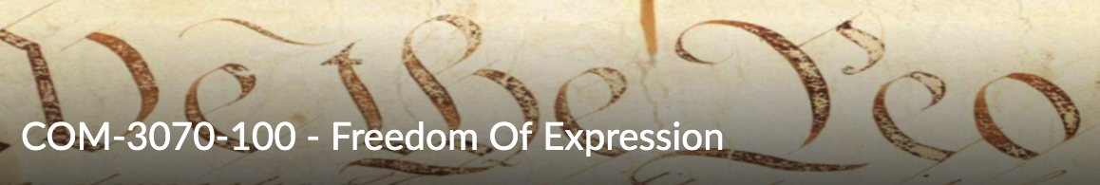  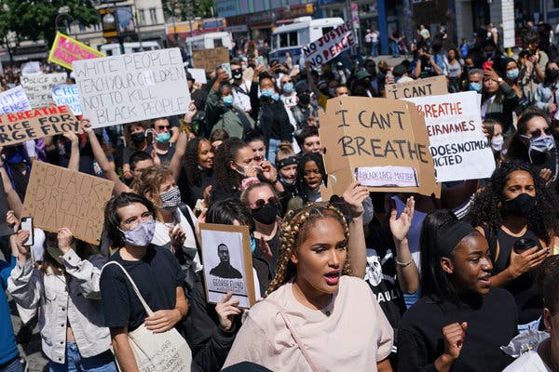 | Richard A. Gershon, Ph.D.  Western Michigan University  School of Communication  Kalamazoo, MI 49008  Email: Richard.Gershon@wmich.edu  Web Site: http://www.rgershon.com

COURSE DESCRIPTION

Freedom of Expression examines the meaning, scope and challenge of free expression
in the American experience. This course provides a series of portraits of people and events that
have fully tested the boundaries of the First Amendment from America’s early beginnings to the
present day. Beginning with the historical foundation of the U.S. Constitution, we will critically examine how the courts, writers, politicians, artists and social activists have interpreted and applied these rights to a number of challenging issues. Such topics include, the politics of the Covid-19 pandemic, social justice and Black Lives Matter, fake news and the weaponization of information and the January 6, 2021insurrection on the U.S. Capitol building in Washington, D.C. to name only a few. Consider, for example, the politics of the Covid-19 pandemic and the wearing of face masks. The facemask has become the visual shorthand for the debate pitting those willing to follow national CDC healthcare guidelines versus those who feel it violates their personal freedom and/or who think the threat is overblown. Another goal of this course is to examine the deeper and richer question; what does it mean to be an American? We look at such issues as the importance of civic engagement.

COURSE OUTLINE
_______________________________________________________________________________
Class Meetings:
_______________________________________________________________________________
I. FREEDOM OF EXPRESSION: Historical Lens and Perspective

Session 1. The American Revolutionary War: Causes and Consequences

- The Causes
- Battles of Lexington and Concord
- 3rd Continental Congress
- The Declaration of Independence
- Battle of Yorktown
  - John Adams I. (Film)

Session 2. American Political Thought

- George Washington
- John Adams
- Thomas Jefferson
- Alexander Hamilton
- Federalists v. Democratic Republicans
  - Jefferson, Hamilton (Doc).

Session 3. The U.S. Constitution

- Constitutional Beginnings
- The Role of James Madison
- Separation of Powers
- The Bill of Rights
- 1st Amendment and Due Process
  - John Adams II. (Film)

Session 4. The First Amendment

- The Press
- News Media and the 4th Estate
- Prior Restraint
  - John Peter Zenger
- Implied Rights
_____________________________________________________________________
End of Part I.

____________________
Exam I.
____________________

II. FREEDOM OF EXPRESSION: Political Science Lens and Perspective

Session 5. Prior Restraint

- Political Dissent is Not Absolute
- The Alien Sedition Act of 1798
- Freedom of Speech and the Antislavery Cause
  - Reverend Elijah Lovejoy
  - William Lloyd Garrison
  - Cassius Marcellus Clay
- Espionage Act of 1917
- Schenk v. U.S., 1919
  - Clear and Present Danger Standard
- Alien Registration Act (Smith Act), 1940
- Anticommunism and the Hollywood 10
- McCarthyism (Red Scare Period) 1951-1954
- U.S.A. Patriot Act, 2001, personal freedoms
  - Newsroom lead-in (Doc.)
  - Murrow v. McCarthy (Doc.)

Session 6. Social Justice and Black Civil Rights

- Social Justice
- Black Civil Rights
  - Frederick Douglas
  - Reconstruction following the Civil War
    - Jim Crow Laws
  - Plessy v. Ferguson, 1896 case
  - Brown v. Board of Education, 1954 case
  - Voting Rights Act of 1965, Civil Rights Act of 1968
  - Martin Luther King
  - Freedom Riders
  - Great Migration
  - Black Lives Matter
    - Trayvon Martin
    - Charleston, SC Shooting
    - George Floyd
  - Colin Kaepernick

Session 7. Social Justice and Women’s Issues

- Women’s Rights
  - The Women’s Suffrage Movement
    - Elizabeth Cady Stanton
    - Susan B. Anthony
    - Lucy Stone
    - Sojourner Truth
  - 19th Amendment to the Constitution
  - Margaret Sanger, family planning
  - Pro-Choice v. Right to Life
  - Brief History of Feminism
    - Gloria Steinem
    - Hillary Clinton
  - Title Nine
  - Me Too Movement

Session 8. Social Justice and Lesbian, Gay, Bisexual, and Transgender

- LGBQ
- Diversity and Inclusion, principle of
- Advancing the Cause
  - Harvey Milk
  - Matthew Sheppard
  - Cleve Jones
- Transgender Legal Cases
  - Obergefell v. Hodges (2015)
  - Bostock v. Clayton Country, GA (2020)
Session 9. The Public’s Right to Know
- From Muckrakers to Investigative Journalists
- Public’s Right to Know
  - N.Y. Times v. U.S., (Pentagon Papers) 1971
  - Watergate, 1974
  - Julian Assange, Wikileaks
  - Edward Snowden, U.S. Surveillance programs
- Reporter’s Privilege
  - Freedom of Information Act
  - Shield Laws
  - Julian Assange Interview (Doc.)
  - Edward Snowden Interview (Doc.)

Session 10. Presidential Addresses

Presidential Addresses
- Abraham Lincoln
  - Gettysburg Address
- Franklin Roosevelt
  - Declaring War on Japan
- John Kennedy
  - Inauguration Speech
  - Cuban Missile Crisis
- Ronald Reagan
  - Space Shuttle Challenger Disaster
  - Presentation at the Berlin Wall
- Bill Clinton
  - Oklahoma City Bombing
- Barack Obama
  - Presidential post-Election Speech, 2008
_____________________________________________________________________
End of Part II.

____________________
Exam II.
____________________

III. FREEDOM OF EXPRESSION: Legal Lens and Perspective

Session 11. Symbolic Speech I.

- Semiotics
- Symbols and Everyday Life
- United States v. O'Brien, 1968
  - Burning Military Draft Cards
- Texas v. Johnson, 1989
  - Burning the U.S. Flag
- Walker v. Texas Division - Sons of Confederate Veterans, 2015
  - License Plates with Possible Offending Message

Session 12. Symbolic Speech II. Rites and Rituals -- Remembering the Fallen

- Archetypes
- Shrines and Monuments
- The Statue of Liberty
- War Memorials
- Maya Lin, the Vietnam Veteran’s Memorial
  - Maya Lin (Doc.)
- The National September 11th Memorial and Museum

Session 13. Hate Speech

- Chaplinsky v. New Hampshire, 1942
  - Fighting Words Doctrine
- Brandenburg v. Ohio, 1969
  - Inciting People to Riot
- The March on Skokie, IL.,1977
  - Freedom to Assemble
- Doe v. The University of Michigan, 1989
  - Political Correctness and University Speech Codes
- RAV. v. The City of St. Paul, MN, 1992
  - St. Paul Bias Motivated Crime Ordinance
- Westboro Baptist Church, 2011
  - Freedom to Assemble
  - Taking Chance (Film)

Session 14. Due Process and the News Media

- The Court of Public Opinion
  - Confirmation Hearing, Justice Clarence Thomas
- Charles Lindbergh Case
  - State of New Jersey v. Richard Bruno Hauptman
- O.J. Simpson Case
  - State of California v. Orenthal James Simpson
- Duke University Rape Case
- The Debbie Almontaser case
- Responsibility of the News Media

Session 15. Due Process and Wrongful Conviction

- Wrongful Conviction
  - Prosecutorial Misconduct
  - Withholding Evidence
  - Rush to Judgment
  - Misidentification and False Testimony
- The Innocence Project
- Ronald Cotton
- Audrey Edmunds
- Ray Hinton
- Michael Morton
  - Michael Morton (Doc.)

________________________________________________________________________
End of Part III.

____________________
Exam III.
____________________

IV. FREEDOM OF EXPRESSION: Comm. Arts Lens and Perspective

Session 16. American Originals I. Painters and Photographers

- Norman Rockwell, painter and illustrator
- Ansel Adams, photographer
- Dorthea Lange, photographer
- LeRoy Neiman, painter
- R.C. Gorman, painter
- Annie Leibovitz, photographer
- Kehinde Wiley, painter
- Stephen Holland, painter

Session 17. American Originals II. Sculptures and Displays
- Norman Rockwell, painter and illustrator
- Ansel Adams, photographer
- Arlington National Cemetery, 1864
- The Statue of Liberty, 1886
- The Abraham Lincoln Memorial, 1920
- Mount Rushmore, 1927 (construction began)
- The Golden Gate Bridge, 1937
- St. Louis Gateway Arch, 1965
- The Vietnam Veteran’s Memorial, 1982
- The Martin Luther King Jr. Memorial, 2011

Session 18 The Mythology of the American Super Hero

- The Role of Super Heroes and Myth
- American Superheroes
- The Origins of Superman
- The Power of Masks
- The Hero of a Thousand Faces
- The Hero’s Journey
  - Dave (Film)

Session 18. Everyday Heroes: Freedom of Expression at its Best

Principles of Civic Engagement
From Superheroes to Everyday Heroes
- Adventure:
  - The American Space Program
  - Neil Armstrong and the Apollo Space Mission
- Courage
  - The N.Y.C. Firemen of 911
- Athletics
  - Jackie Robinson
  - U.S. Women’s Soccer, World Cup, 1999
  - U.S. Men’s Hockey, 1980 Olympic Winter Games
  - Miracle on Ice (Doc.)

________________________________________________________________________
End of Part IV.

____________________
Exam IV.
____________________

Prerecorded Sessions
In addition, there will be a series of presentations that will be prerecorded.
I offer you the opportunity to see these presentations at your convenience. They are highlighted in blue on your course syllabus. They, like all my presentations, will be posted to the course website and E-learning.

Readings, Video Links and Major Television/Film Presentation
Each class session will be accompanied by a set of on-line readings and/or video links that provide good background information to the material being presented. I strongly encourage you to complete the readings and video-links in keeping with the course schedule. It will make my presentation and our work together more accessible.
They will be posted to my course website and E-learning site. In addition, many of our classes together will feature a television special/documentary or a major film to be seen in conjunction with the in-class presentation.

________________________________________

Grading Scale:

93-100A 70-75 C
87- 92 B/A 65-69 D/C
82- 86 B 60-64 D
76- 81 C/B -59 E
________________________________________

