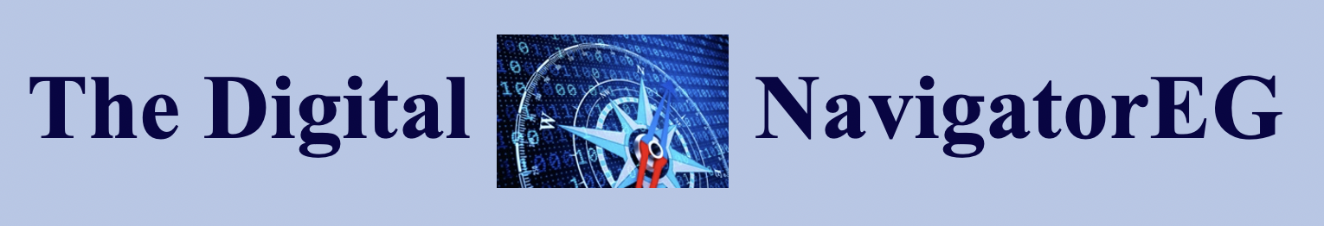

The Innovator’s Dilemma: Briefing Paper
Richard A. Gershon, Ph.D.
In 1997, Harvard University Professor Clayton Christensen (1997) developed a working theory
known as the innovator’s dilemma; namely, that a company's very strengths (i.e., successful product
line, consistent profitability and growth) now become barriers to change and the agents of
a company’s potential decline. Successful companies are highly committed to serving their existing
customers and are often unable (or unwilling) to take apart a thriving business in favor of developing
an unproven new technology or service. Worst still, the start-up of a new technology or service
requires expensive retooling and whose ultimate success is hard to predict. In time, such companies
lose because they fail to invest in new product development and/or because they fail to notice small
niche players who enter the market and are prepared to offer customers alternative solutions at
better value. The anticipated profit margins in developing a future market niche can be hard to
justify given the high cost of entry; not to mention the possible destabilization of an otherwise
highly successful business. Therein, lies the innovator’s dilemma.
The Innovator’s Dilemma and Product Life Cycle
Product Life Cycle theory was first proposed by Raymond Vernon (1966) and explains
the evolution of a product development from the point of its introduction into the marketplace

to its final stages of decline. The theory of product life cycle has evolved over the years and has

come to include a series of four stages, including: 1) Introduction,2) Growth, 3) Maturity

and 4) Decline. After a product or service is launched, it goes through the various stages of
a life cycle and reaches a natural decline point. Part of the innovator’s dilemma is to know when

in the course of the product life cycle to innovate. (See Figure 1). The decision to innovate

represents a strategic choice to discontinue (or phase out) a mature product in favor of an untested

one. The decision to innovate has to occur well before the product hits its decline phase in order

to allow sufficient time for development.

Figure 1
The Innovator’s Dilemma and Product Life Cycle

Introduction Growth Maturity Decline
 |  | Sales Volume | Innovator’s Dilemma  ?

The history of media and telecommunications is replete with examples of companies

faced with the innovator’s dilemma. Such examples can be seen with companies like Eastman

Kodak, Blockbuster Video, Nokia and Radio Shack. This means that the critical decision has

to occur during the very time when the product is mature and realizing its highest profits.

The downside risk is that the manufacturer may get it wrong and thereby destabilize an otherwise

highly successful product line. It is worth noting that many companies that are highly regarded

as innovative can momentarily lose their innovative edge only to rebound at a later time

(i.e., IBM, Walt Disney, Apple, Sony etc.). In sum, few companies are able to remain consistently

innovative across time.
Sources:
Christensen, C. (1997). The Innovator’s Dilemma. Boston, MA., USA: Harvard Business
School Press.

Davila, T., Epstein, M. & Shelton, R. (2006). Making Innovation Work. Philadelphia, PA. USA: Wharton School Publishing.

Gershon R.A. (2017). Digital Media and Innovation: Management and Design Strategies
in Communication. Thousand Oaks, CA: Sage, pp. 92-93, 96-98.

Vernon, R. International Investment and International Trade in the Product Cycle.
Quarterly Journal of Economics, 80,2 (1966): 190-207.

Contact: Richard A. Gershon
Email: Richard.Gershon@wmich.edu
Website: Digitalnavigatoreg https://www.digitalnavigatoreg.com/

