The Diffusion of Innovation Revisited
Richard A. Gershon
_______________________________
Introduction
In 1962, communication scholar Everett Rogers wrote the first edition of his seminal work Diffusion of Innovations. This book is considered a classic in the field of communication and has subsequently gone through multiple editions and updates since that time. Diffusion of innovation is a set of theories that seeks to explain how new ideas and technologies diffuse though a specific population.1 It further considers the rate of adoption, that is, the speed at which some members of a social system accept, reject, or delay an innovative change or practice. Anyone purporting to effect change, whether it be an educator, health-care professional, or marketing specialist needs to understand the rate of adoption process. Whereas the basic principles of diffusion of innovation have stayed the same since Rogers first introduced the concept, what’s different today is the speed at which new product launches and introductions are diffused into the public sector. Terms like diffusion, communication channels, and members of a social system take on a whole new meaning when we consider them in light of today’s digital media environment. Digital storytelling is the art of using electronic media and information tools to tell a story. From online newspapers to social media, digital storytelling assumes a wide range of electronic media narratives. It has greatly increased the speed at which a product, service, or idea can be diffused.
Diffusion of Innovation
Rogers (2003) defines diffusion as “the process by which an innovation is communicated through certain channels over time among the members of a social system. Rogers’s definition contains four elements that are present in the diffusion process. They include: 1) Innovation, 2) Communication channels, 3) Time, and 4) Members of a social system.
Rate of Adoption
The term rate of adoption refers to the length of time required by someone to consider and adopt the use of a new technology or service. Some users of communication and IT are technology enthusiasts. They are naturally curious and experimental and want to be among the first to adopt a new product offering. In contrast, there are others who are more cautious in their approach to the adoption of a new technology or service. The rate of adoption can be defined as the “relative speed at which members of a social system adopt an innovation.” It can be depicted as a standard bell curve, with innovators and early adopters at the front end and laggards (or late adopters) at the back. There are five general categories of adopters, including: 1) Innovators, 2) Early adopters, 3) Early majority, 4) Late majority, and 5) Laggards. (See Figure 6.2.)

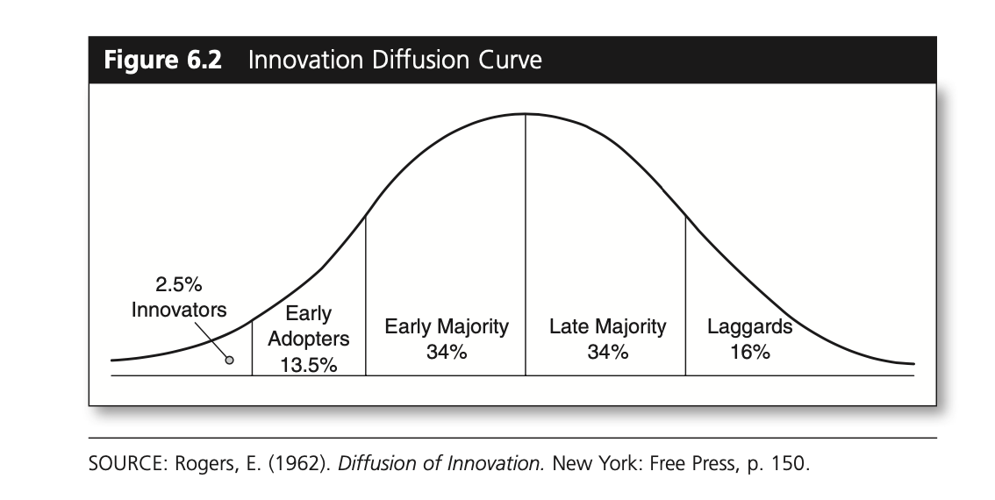
Innovators
Innovators are technology enthusiasts. They are the first to adopt a new tech- nology or service. Innovators represent a fairly elite set of users whether we mea- sure them in terms of education level, income, or occupation. They have a higher degree of risk tolerance since the potential investment in the said technology or service may fail.11 The commitment, therefore, is not trivial when it comes to things like the first generation of high-definition television sets, smartphones, or iPad computer tablets. The motivation for making such purchase decisions can be for business and research, but likewise, it can be based on genuine interest and enthusiasm for the product. And for some individuals, the decision can be a statement about social status. Innovators tend to have greater financial resources with which to pursue their personal and professional interests.
Early Adopters
Early adopters comprise the second-fastest category of individuals who adopt an innovation. Such individuals are typically younger in age and have advanced educations as well as greater financial resources. Early adopters tend to be people with high-prestige positions, including doctors, lawyers, scientists, engineers, and educators. They like having the newest technology or service when it becomes available.12 At the same time, they tend to be more discerning in their adoption choices than innovators. Early adopters are often considered opinion leaders within the groups or organizations that they participate in. In sum, there is a posi- tive correlation between socioeconomic status and early adoption.
Early Majority
The early majority represents a large segment of the general public. Early major- ity adopters are genuinely interested in acquiring the newly introduced technology or service. But the rate of adoption tends to be slower. This category of users tends to be more cautious in their approach. Price and product reliability matter.13 Product introductions are typically priced higher when compared to the second or third generation of that same product. Early majority users recognize that with the intro- duction of any new product or service comes a period of adjustment where design issues or flaws may surface. The early majority prefer to wait and allow the new product or service to prove itself in the marketplace.
Late Majority
Individuals in this category tend to be more resistant to change when it comes to new technologies and services. Late majority individuals will adopt an innovation well after the product introduction. They display a high degree of skepticism about the product or service. They are quite content to make do with their current technology or service. In some cases, the resistance factor is due to a lack of interest (i.e., too complicated, not needed, content with what I’ve got, etc.), whereas in other instances the reason can be attributed to a lack of financial resources.
Laggards
Laggards are the last to adopt an innovation. Such individuals are typically older and more resistant to change. They don’t see the practical need for making the change until a friend or family member prompts them to think about making one. Late adopters are more reluctant to spend money on new technologies. They tend to place a greater emphasis on the value of family and tradition. Categorically, late adopters have less discretionary income and tend to be more resistant to change. Both late majority and laggards tend to exhibit little in the way of opinion leadership.
Gershon R.A. (2017). Digital Media and Innovation: Management and Design Strategies
in Communication. Thousand Oaks, CA: Sage, pp. 92-93, 96-98.

