

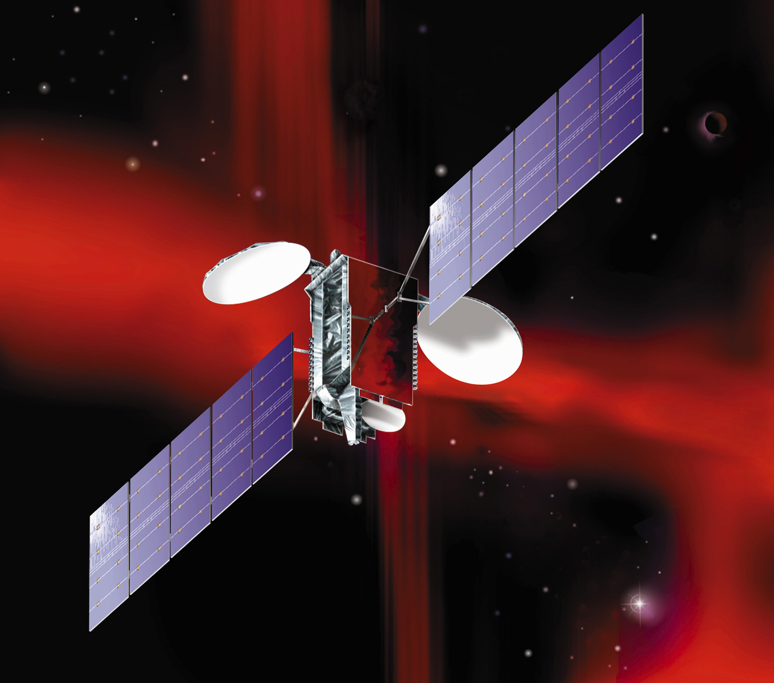

**Satellite Communication: Briefing Paper   
 Richard A. Gershon, Ph.D.**

A communication satellite is essentially a microwave relay in the sky, operating at 22,300 miles

above the earth's equator. It receives microwave signals in a given frequency and retransmits

them at a different frequency. Satellites provide an efficient means of reaching isolated places

on the earth and are considerably less expensive than terrestrial communication links for select

applications. Communication satellites are a versatile form of wireless communication.

What distinguishes communication satellites from other forms of wireless communication

(broadcasting, cellular telephone etc.) is its high orbital position and movement.

**Geosynchronous Orbit**

The term “geosynchronous orbit” refers to a satellite that operates at 22,300 miles above the

earth’s equator. The satellite rotates at the speed of the earth. Hence, the satellite appears to

be stationary in its orbital position.

**Fixed Satellite Services (FSS)**

The term Fixed Satellite Services (FSS) is used to describe satellites that operate in the GSO.

Satellites that operate in the GSO can provide 24 hour service which is essential for broadcast

television, cable television, telephone and Internet communication.

**Satellite Links**

In principle, a complete satellite link requires a line of sight path extending between the earth

station and the satellite. The term *uplink* refers to that portion of the satellite link where a signal

is being transmitted from the earth station to the satellite. The term *downlink* refers to that

portion of the satellite link where a signal is being transmitted from the satellite to the earth

station below. See Figure 1.

**Figure 1.**

**Satellite Transmission Link**

|  |
| --- |
| Illustration: Chan, Chin Bong |

**Transponder**

A transponder is a contraction of two words: transmitter and responder. A transponder

is analogous to a channel. A transponder provides the connection between the satellite’s

receiver and transmit antennas. It receives the signal in one frequency and then converts

it to another for the down-link portion. Satellites operate in the Super High Frequency (SHF)

range which is measured in GHz. or billion cycles per second. Satellite engineers recognize

that the higher the frequency, the greater the susceptibility to weather conditions, which can

degrade performance. Therefore, the higher frequency is always assigned to the uplink

portion, whereas, the lower frequency is assigned to the downlink.

A communication satellite contains 24 – 96 transponders plus spares depending

on the size of the satellite. The transponder bandwidth can vary in size, ranging between

36MHz., 54 Mhz. or 72MHz. A single transponder can deliver a digital combination of voice,

data and television channels. Many of today’s satellites use a hybrid approach; that is,

a combination of C and Ku band set of transponders. Subsequent improvements in Digital

Video Compression using an MPEG 2 or MPEG 4 standard format allows satellite common

carriers to maximize their transponder delivery capability. This becomes especially important

when it come to the delivery of cable television and DBS video signals.

**Satellite Frequency Bands**

International satellite communication requires that all fully deployed satellites be assigned

a frequency according to class of service (i.e., application) and power levels. Satellite frequency

assignments are fully administered and regulated under the auspices of the International

Telecommunications Union (ITU) in cooperation with a host country’s major communication

regulatory agency. Media and telecommunications companies like cable television have a need

to down convert satellite frequencies and manipulate the signal within the confines of their

master antenna site facility. The cable facility must be able to manipulate and transport the data

without causing undue interference with other radio communications in the area.

**Footprint**

A satellite footprint refers to the signal's area of coverage. Premium television services,

for example, like HBO utilizes a east Coast and West Coast feed in order to blanket the entire

U.S. Similarly, Direct Broadcast Satellite (DBS) services like DirecTV have a fleet of satellites

but use three primary satellites for distributing their signal in the U.S. Therefore, any earth

station that falls within the footprint of a satellite fed signal and that is locked on to the

appropriate transponder is capable of receiving the same signal. Figure 2. illustrates a satellite

footprint and its coverage in North America. Figure 2. provides a second example of a satellite

footprint whose area of coverage includes Europe, the middle east and major portions of Russia.

**Figure 2.**

**Satellite Footprint Display**



Sources: Chan Chin Bong and Intelsat

**Earth Station**

The earth station (or satellite dish) is the antenna that receives satellite fed voice, data and

video signals. While some earth stations are capable of transmitting and receiving signals, most

satellite dishes such as a cable head-end or DBS receiver is a television receive only (TVRO)

device. The satellite dish contains a parabolic reflector as well as the internal electronics for

downlinking and converting the signal. By forming an arc, the parabolic dish concentrates

incoming signals to a small point at the center above the dish. (See Figure. 3). The larger

the diameter of the reflecting surface, the greater the sensitivity to weak incoming signals.

Once the signal has been concentrated and delivered to the focal point, it must be collected

and passed on with a minimum of signal loss.

**Figure 3.**

**Satellite TVRO Earth Station**

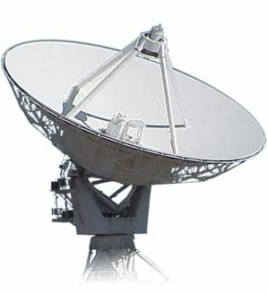

Source: Gershon R.A. (2013). *Media*, *Telecommunications and Business Strategy*. (2nd ed.)

New York: Routledge.

Contact: Richard A. Gershon

Email: [Richard.Gershon@wmich.edu](mailto:Richard.Gershon@wmich.edu)

Website: Digitalnavigatoreg <https://www.digitalnavigatoreg.com/>