Here’s to the Dreamers…
Richard A. Gershon
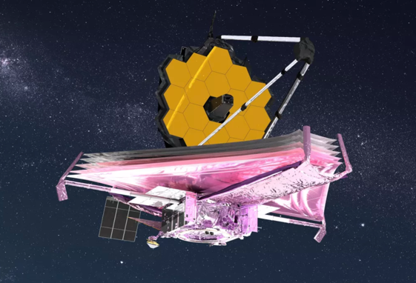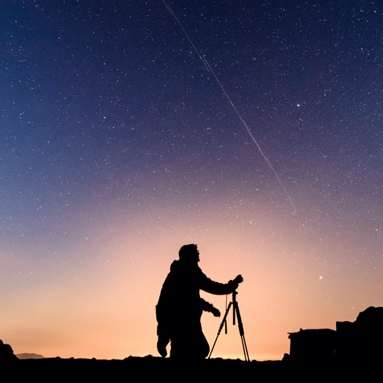
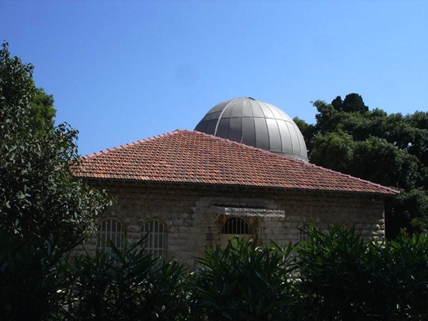
Lee Observatory

Yesterday, was a cold and rainy day in New Bern, North Carolina; the type of day
that my wife Casey undertook to sort through some very old letters. These letters
were contained in a series of very old boxes; something that she would get to – sometime in the future when she retired. Several of those letters included her Grandfather, Dr. Julius Arthur Brown; a Professor, Rhodes Scholar and astronomer
at the American University in Beirut, Lebanon. These were the stories of one man;
a lone astronomer with a telescope peering up at the stars in the 1920s on the outskirts of Beirut at the Lee Observatory. At the time, the night sky in Beirut was considered one of the clearest anywhere in the world.

Here we are, a hundred plus years later, and NASA just launched the James Webb Space Telescope’s from Europe’s Spaceport in Kourou, French Guiana. The Webb Space Telescope became fully deployed last week and is an international partnership comprised of NASA, the European Space Agency and the Canadian Space Agency. The Webb Space Telescope is the most powerful telescope built to date whose mission is to explore cosmic geography and history – from within our solar system to the most distant observable galaxies. Here’s to the dreamers in all of us who reach for the stars…

