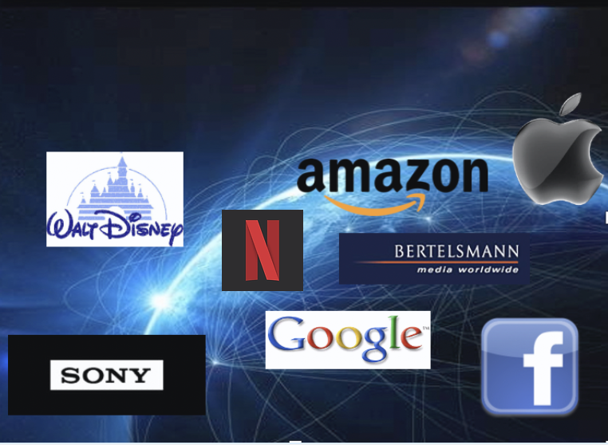

Transnational Media and Foreign Direct Investment: Briefing Paper
Richard A. Gershon, Ph.D.
Professor Emeritus, School of Communication
Western Michigan University

The transnational media corporation (TNMC) is a nationally based company with overseas operations in two or more countries. One distinctive feature of the TNMC is that strategic decision making and the allocation of resources are predicated upon economic goals and efficiencies with little regard to national boundaries. The TNMC is the most powerful economic force for global media activity in the world today. Through a process of foreign direct investment, the TNMC actively promotes the use of advanced media and information technology on a worldwide basis. Examples of such companies include, Google, The Walt Disney Company, Apple, Sony, Facebook, Netflix, Amazon and Bertelsmann to name only a few. They have become a salient feature of our present-day global economic landscape.
The Globalization of Markets
The globalization of markets involves the full integration of transnational business, nation
states, and technologies operating at high speed. Globalization is being driven by a broad
and powerful set of forces including worldwide deregulation and privatization trends as well
as advancements in new technology; most notably, the Internet and the power of intelligent
networking. This is fully evident in the development of such things as electronic commerce,
social media and over-the-top video streaming services. The basic requirements for all
would-be players are free trade and a willingness to compete internationally.
The Purpose of a Global Business Strategy
Most companies do not set out with an established plan for becoming a major international company. Rather, as a company's exports steadily increase, it establishes a foreign office to handle the sales and services of its products. In the beginning stages, the foreign office tends
to be flexible and highly independent. As the firm gains experience, it may get involved in
other facets of international business such as licensing and manufacturing abroad. Later, as pressures arise from various international operations, the company begins to recognize the
need for a more comprehensive global strategy. In sum, most companies develop a global business strategy through a process of gradual evolution rather than by deliberate choice.
FOREIGN DIRECT INVESTMENT
Foreign Direct Investment (FDI) refers to the ownership of a company in a foreign country.
This includes the control of assets. As part of its commitment, the investing company may
build a manufacturing or distribution facility as well as transfer some of its managerial,
financial and technical expertise to the foreign owned company. The decision to engage in
FDI is based upon the profitability of the market, growth potential, regulatory climate and
existing competitive situation. There are four reasons that help to explain why a company
engages in FDI. They include: 1) Proprietary Assets and Natural Resources, 2) Foreign
Market Penetration, 3) Research, Production and Distribution Efficiencies and 4) Overcoming
Regulatory Barriers to Entry.
Proprietary Assets and Natural Resources.
Some TNCs invest abroad for the purpose of obtaining specific proprietary assets and natural resources. The ownership of talent or specialized expertise can be considered a type of proprietary asset. Consider, for example, purchase of Metro Goldwyn Mayer (MGM) Studios
for $5.8 billion in 2004. Rather than trying to create an altogether new company, Sony purchased proprietary assets in the form of exclusive contracts with some of the world's leading television and film producers. Sony was well positioned to combine the company’s technology expertise with their newly acquired television/film production capability. Today, Sony Pictures Entertainment’s motion picture library is internationally recognized and one of the company’s most valuable assets, featuring more than 3,500 films, including multiple Best Picture Academy Award winners.
Foreign Market Penetration.
Some TNMCs invest abroad for the purpose of entering a foreign market and serving it from
that location. The market may exist or may have to be developed. This is a strategy employed
by many large-scale media and information technology companies. One such example
can be seen with OTT video streaming services such as Netflix, Disney Plus and HBO Max
that are able to reach a worldwide audience as well as producing local programming that
is specifically tailored to a certain country or region of the world. A variation on direct
market entry approach is for the TNMC to become an international contractor. The TNMC
will sometimes elect to license or franchise a special product or process rather than undertaking
the entire investment by themselves. The Walt Disney Company, for example, is able to
successfully trade on its name worldwide. The formation of Disneyland Paris and Shanghai
Disney are two such examples.
Research, Production and Distribution Efficiencies.
The cost of research, production and labor are important factors in the selection of foreign locations. Some countries offer significant advantages such as a well trained work force, lower labor costs, tax relief and technology infrastructure. Depending upon the country and/or technical facility, products and services can be produced for less cost and with greater efficiency. India, for example, has become an important engineering and manufacturing facility for many computer and telecommunications companies located in the U.S. Another example can be seen with the Foxconn Technology Group located in Taiwan (Republic of China) which is one of the largest consumer electronics manufacturing facilities in the world. FoxConn serves as the main manufacturing site for Apple where it produces the Apple iPhone and iPad devices. Printed on the back of every iPhone is the notation: “Designed by Apple in California -- Assembled in China.” Implied in this statement is the clear separation of responsibilities between product design and manufacturing.
Overcoming Regulatory Barriers to Entry.
Some TNCs invest abroad for the purpose of entering into a market that is heavily tariffed.
It is not uncommon for nations to engage in various protectionist policies designed to protect local industry. Regulatory barriers usually take the form of tariffs, import quotas or civil law suits. One such example can be seen with the May 2018 passage of the European based General Data Protection Act whose aim is to protect consumer privacy. Google, for one, has been engaged
in a longstanding regulatory battle with the European Union. Google has been accused of favoring their own services (i.e., Google Search, You Tube, Maps and Finance) when compared
to European based services in terms of listing priority. Nevertheless, Google is the most popular search engine in Europe. One way to overcome regulatory barriers is to engage the host nation directly by having a local or regional presence that may include building a major manufacturing or production facility such as well as the creation of job opportunities.
The Risks Associated with FDI.
The decision to invest in a foreign country can pose serious risks to the company operating
abroad. The TNC is subject to the laws and regulations of the host country. It is also vulnerable
to the host country's politics and business policies. What are the kinds of risks associated with
FDI? There are the problems associated with political instability including wars, revolutions
and coups. Less dramatic, but equally important, are changes stemming from the election of
socialist or nationalist governments that may prove hostile to private business and particularly
to foreign-owned business. Changes in labor conditions and wage requirements are also
relevant factors in terms of a company's ability to do business abroad. Foreign governments
may impose laws concerning taxes, currency convertibility and/or impose requirements
involving technology transfer.
Consider, for example, the issue of technology transfer. The decision to enter
a foreign market may require the media or information technology enterprise to partner with
a domestic firm in order to gain entry into that country. At issue, is the fact that the domestic
firm will sometimes use that relationship in order to obtain proprietary information. A growing
number of nations rely on forced technology transfer, requiring the establishment of research
and development labs as well as advanced production facilities as part of the cost of doing
business. The challenge, of course, is that today’s business partner can later become one’s
future competitor. In light of such issues, the TNMC will carefully consider the potential risks
by doing what is called a country risk assessment before committing capital and resources.
Sources:
Gershon, R.A. (2020). Transnational media and business strategy: Global messages
in the digital age. In M. Mahoney and T. Tang (Eds.) The Handbook of Media Management and Business. (175-190). New York: Rowman and Littlefield.
Gershon, R.A. (2019). The transnational media corporation and the economics of global competition. In Y. Kamalipour (Ed.), Global Communication. 3rd ed. (pp. 37-54).
New York: Rowman and Littlefield.
Gershon, R.A. (2006). Issues in transnational media management. In A. Albarran, M. Wirth
& S. Chan-Olmsted (Eds.), Handbook of Media Management and Economics. (pp. 203-228). Mahwah, NJ: Lawrence Erlbaum & Associates.
Gershon R.A. (1997). The Transnational Media Corporation: Global Messages and Free
Market Competition. Mahwah, NJ: Lawrence Erlbaum & Associates.

Contact: Richard A. Gershon
Email: Richard.Gershon@wmich.edu
Website: Digitalnavigatoreg https://www.digitalnavigatoreg.com/

